Monesh R
PALO ALTO
INITIAL CONFIGURATION:
Steps
- Login to MGMT

MGMT IP: 1.0.0.10 SUBNETMASK: 255.0.0.0
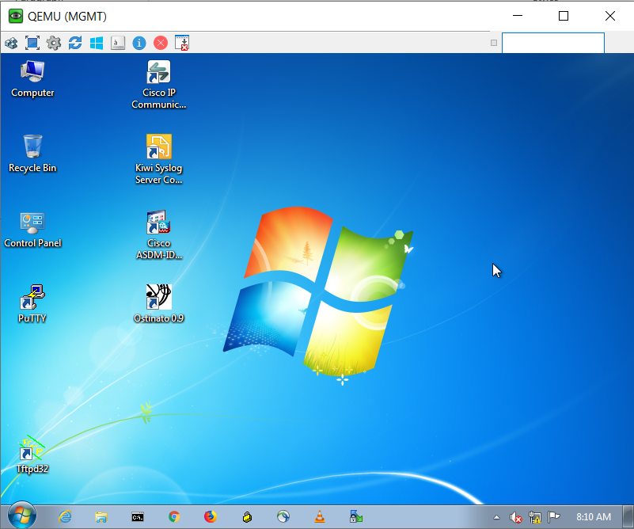
- Next Login to Palo alto

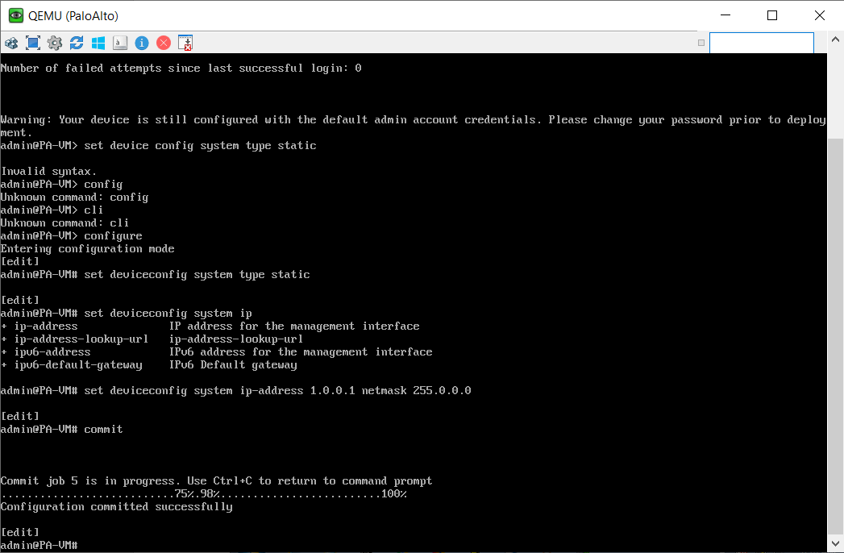

- Assign ip address for management pc and go to GUI of paloalto

PALO IP: 1.0.0.1 SUBNETMASK: 255.0.0.0

Now go to run on windows enter ncpa.cpl

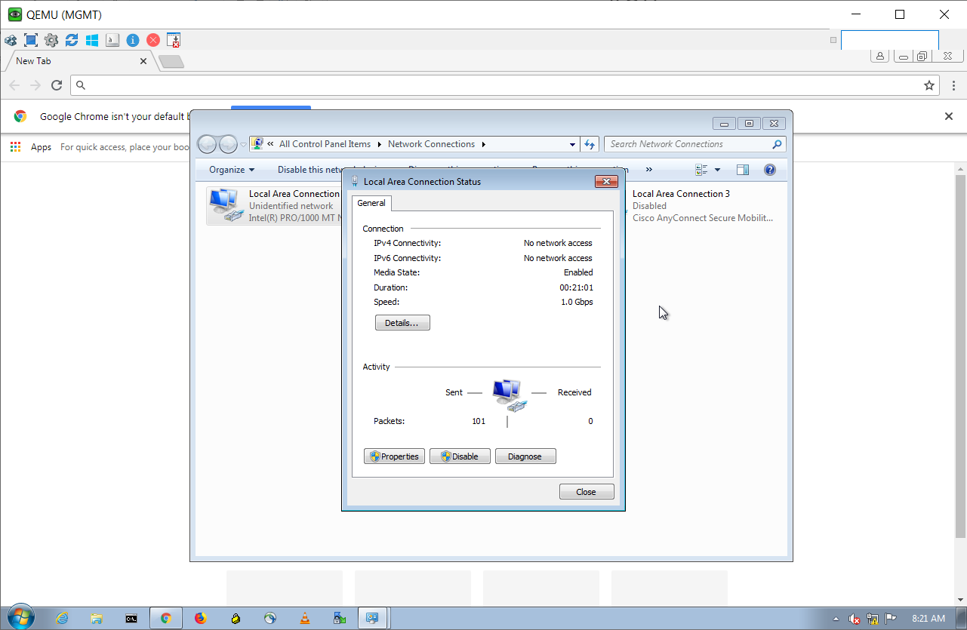

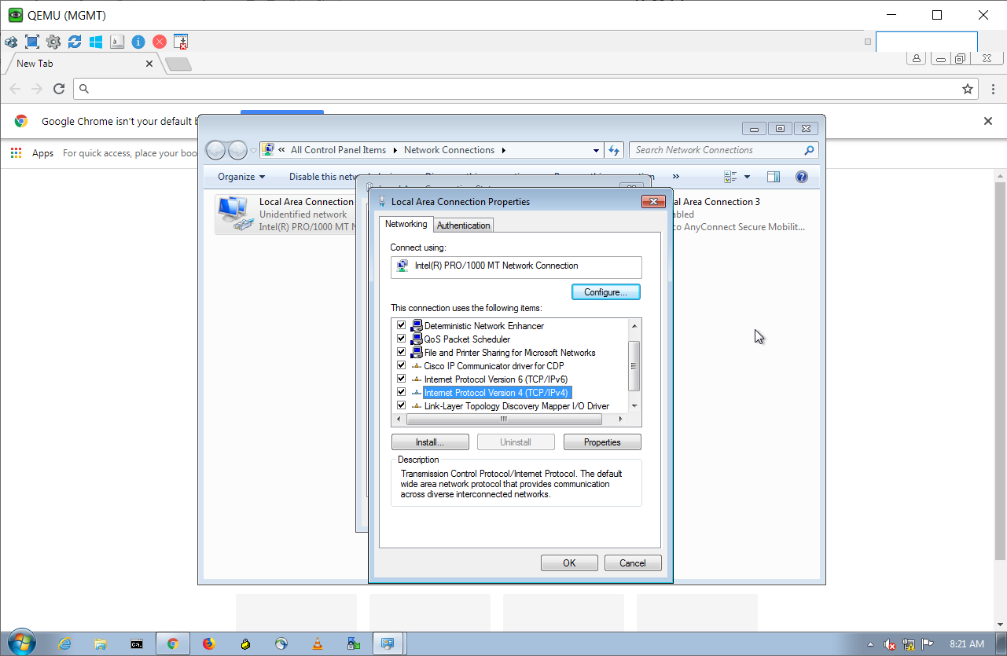

Set the IP, subnet mask and default gateway

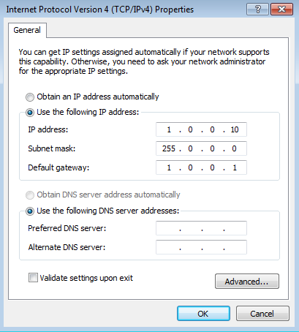

- Now enter IP address – https://1.0.0.1

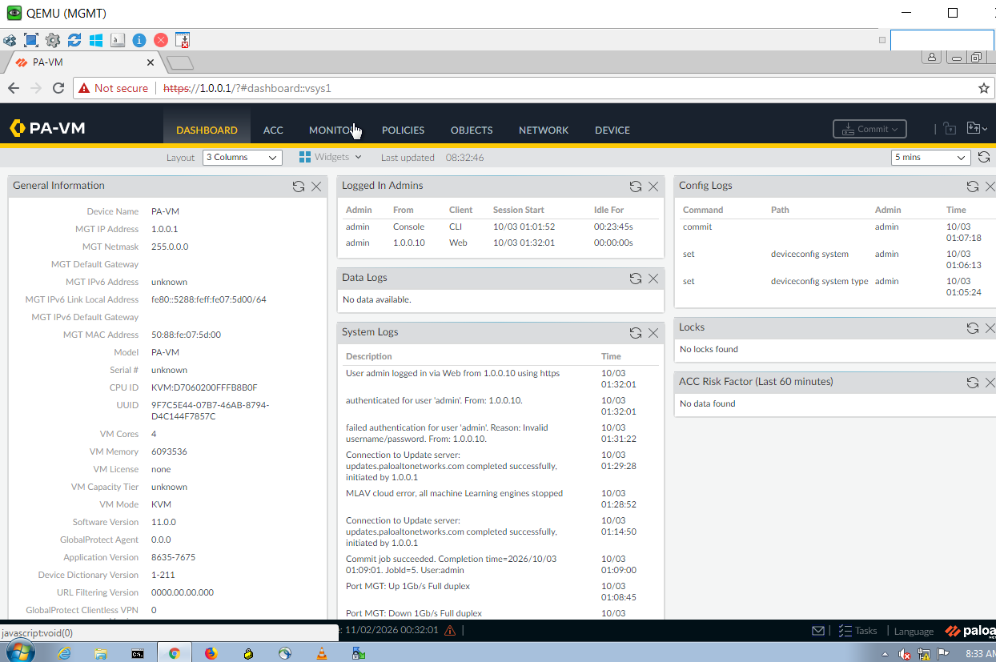

- Go to network create a zones

In this Zones create Inside and outside zone

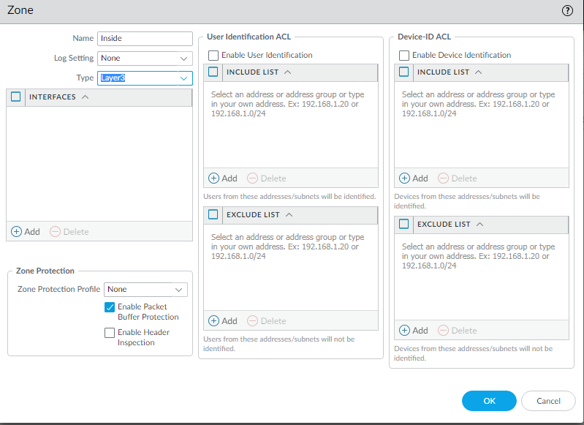

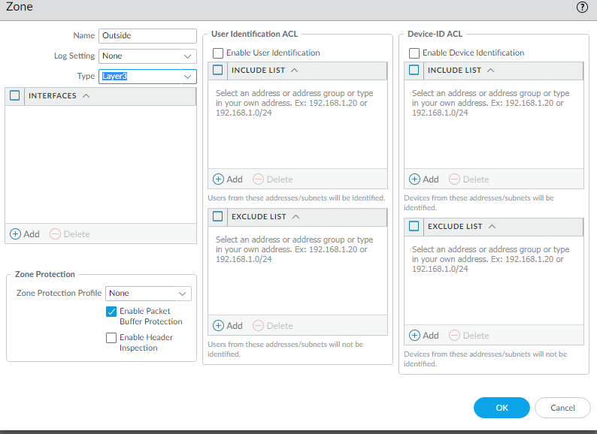

- Go to Interfaces and set Set IP address, Default router, zone to create interfaces
- For Ethernet 1/1 and 1/2

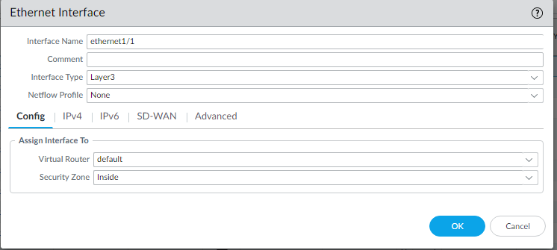
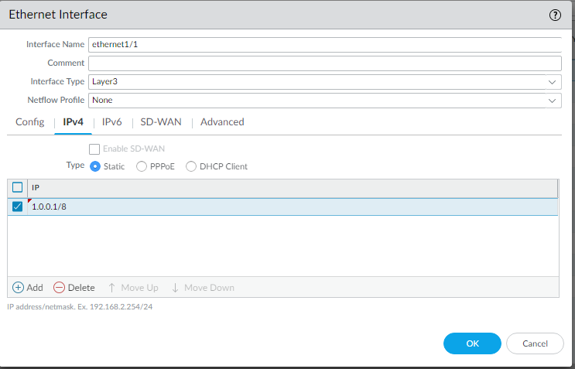
- Add default route to ISP

Select Virtual routers set static routers
Click default in Static routers eth1/1 and eth1/2
Give name: Default

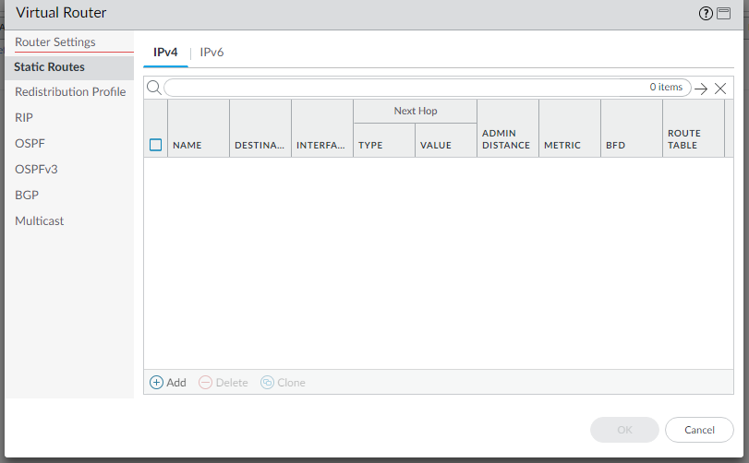

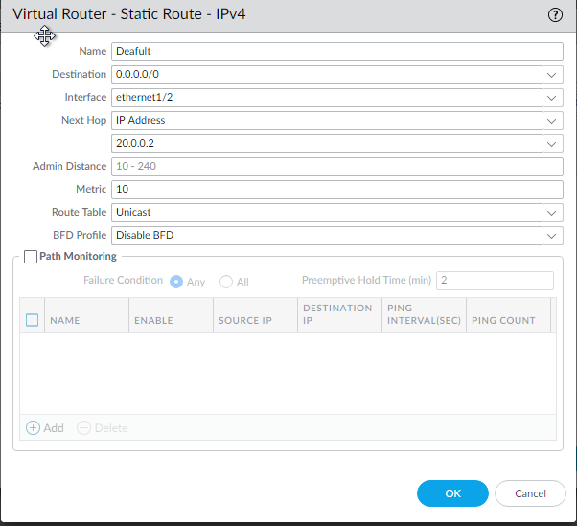

- Select Object and set address

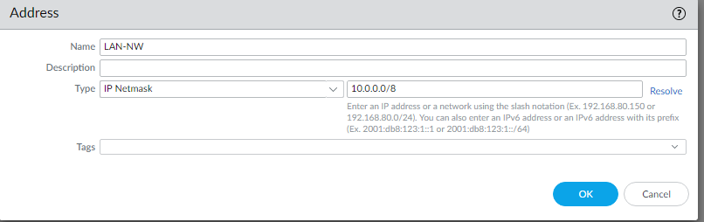

- We want to create DNS is important

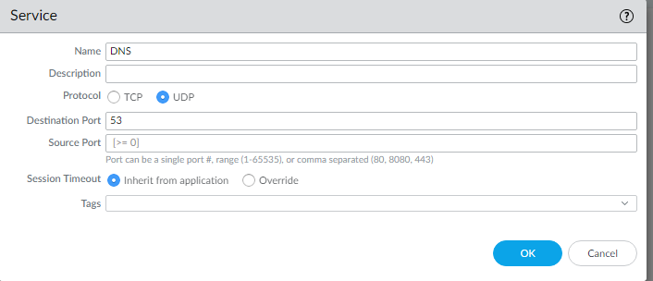
- Create policy for inside and outside

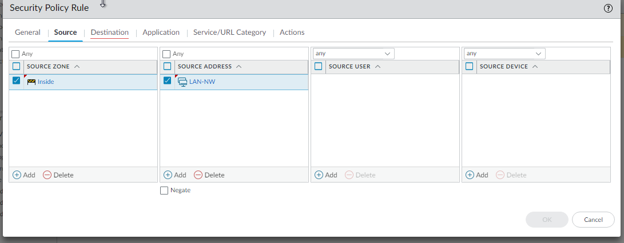

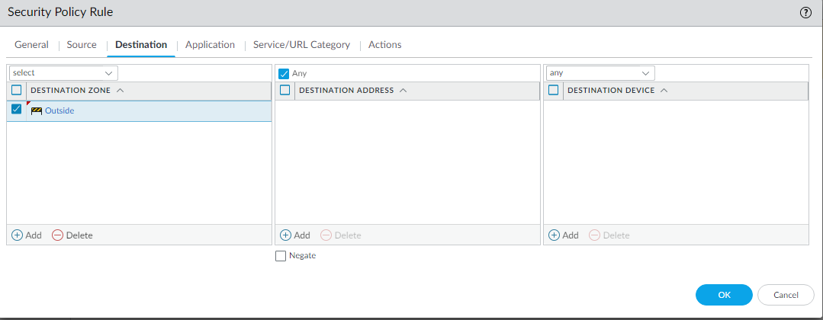

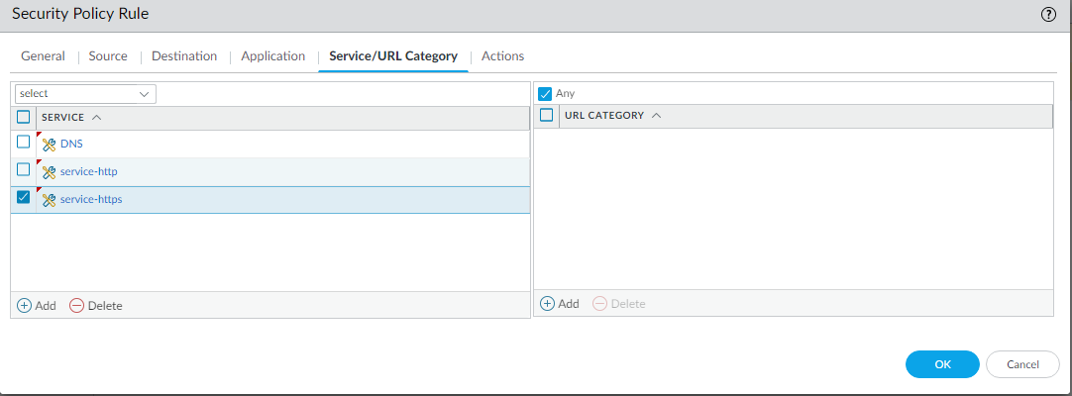
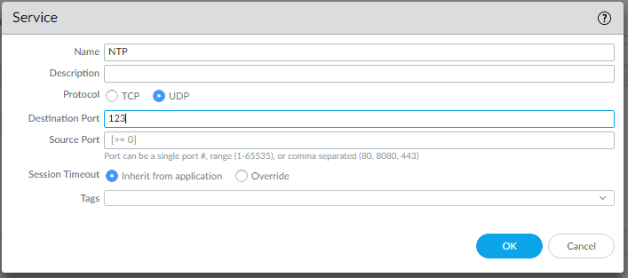

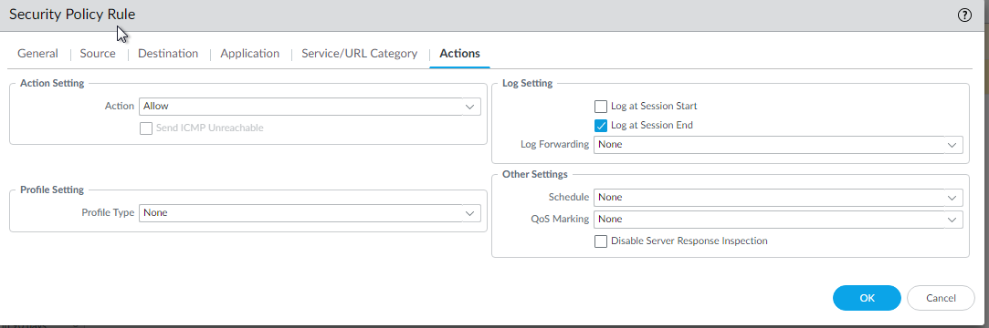

- We want to create NAT policy

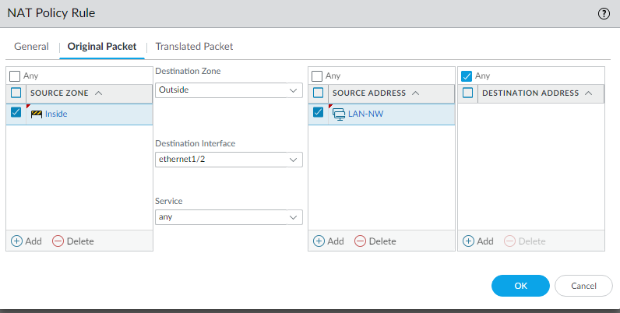
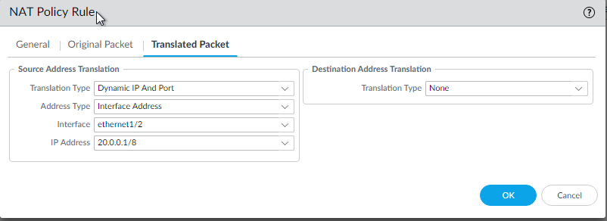

- Enable DHCP for lan interface

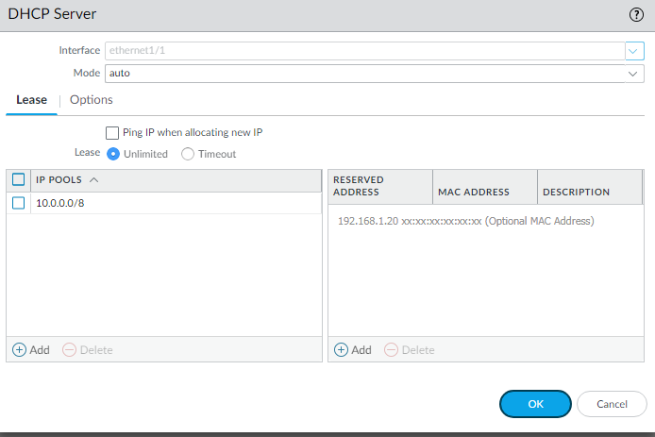

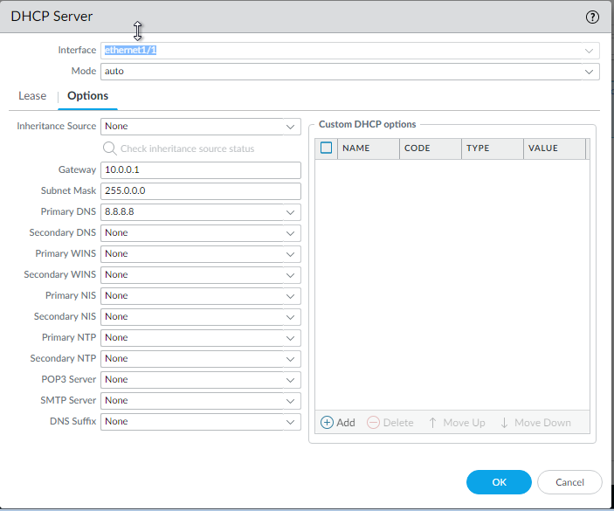

- After configuration finished we want to give commit

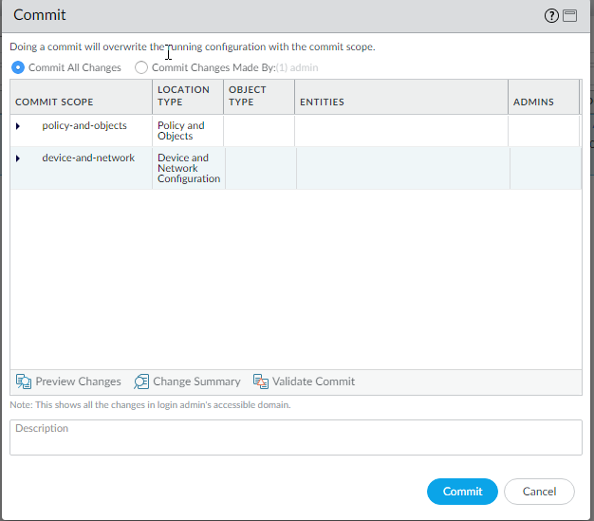

- Now ping 8.8.8.8 from LAN

